Detective
Who: Reception – Year 6
Players: 10+
Time: 10+ minutes
Equipment: None

How to play
- Players form a circle and stand 2 metres away from each other. The facilitator will pick one detective that will leave the circle.
- The facilitator will pick one leader who will start making movements that everyone else in the circle will copy.
- The detective starts in the middle and tries to figure out who is the leader.
- The detective has three guesses. After three guesses, choose a new leader and detective.

Check for understanding
How many guesses does the detective get?
Who do the players copy?

Top tip
Tell students not to give away the leader

Conflict resolution
Have players Wi-Fi (wireless high five or air five) each other

Change it
Easy: Leader can speak
Medium: Have two detectives
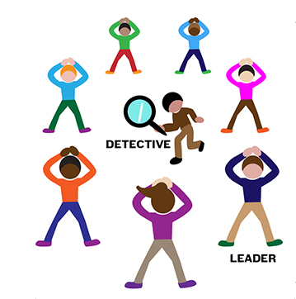
Hard: Have two leaders

