Animal Kingdom
Who: Reception – Year 9
Players: 8+
Time: 10+ minutes
Equipment: None

How to play
- Form a circle and stand 2 metres away from each other. Select one player to be the zookeeper, who will stand in the middle of the circle.
- The zookeeper will close his or her eyes and instruct other players how to move around the circle (skip, run, jump, etc.). Make sure to keep your distance.
- When the zookeeper is ready, he or she says, "freeze," points to someone, and shouts out an animal.
- If you are chosen, you have to make the sound of an animal that the zookeeper says.
- The zookeeper has three chances to guess who made the sound.
- Wi-Fi (wireless high five or air five) the zookeeper. The player who made the animal sound switches places with the zookeeper.

Check for understanding
How many guesses do you have?
When can you go to the middle of the circle?

Top tip
Make sure the zookeeper closes his/her eyes

Conflict resolution
If the zookeeper points between two people, have them do rock-paper-scissors to determine who will make the animal sound

Change it
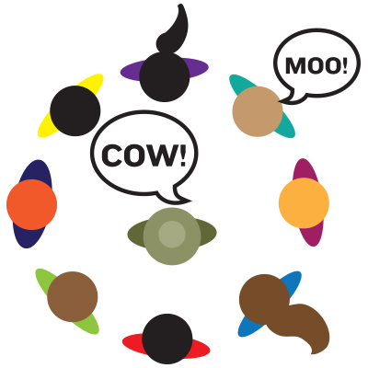
Easy: Zookeeper will guess the noise
Medium: Make the movement of the animal
Hard: Say a word like the animal

