Maths Line
Who: Reception – Year 9
Players: 10+
Time: 10+ minutes
Equipment: Cones

How to play
- Players line up standing 2 metres away from each other. The leader will split players up into teams of three.
- The leader will set up five cones at different distances along one side of the gymnasium or playground.
- When the leader calls out a maths problem (2+1=?), the first player in each line will run the distance to the answer. In this case, three cones.
- Once the first players run back, the next player in each line will run when the leader calls out another maths problem (8-6=?). In this case, two cones.
- Continue the relay until each player gets a chance to run, then start the next round.

Check for understanding
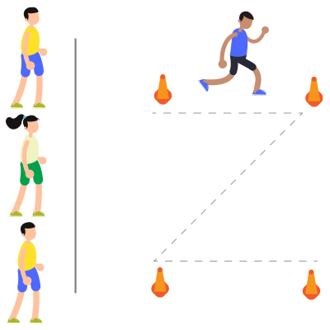
What is 10-5?
What is 2x2?

Top tip
Demonstrate a round before beginning the game

Conflict resolution
Have players cheer each other on

Change it
Easy: Hop, skip or gallop
Medium: Use multiplication
Hard: Use division

