Clap and Move
Who: Reception – Year 3
Players: 10+
Time: 10+ minutes
Equipment: Coloured cones

How to play
- Players line up and stand 2 metres away from each other.
- The leader will clap three times, then say a colour of one of the cones.
- Players run to the cone of the colour that the leader says without touching anyone. Only one person can be at a cone at a time.

Check for understanding
How many claps do players listen for?
Point to the colour cones

Top tip
Players should always be standing 6 feet away from each other

Conflict resolution
Have players help you lead the game

Change it
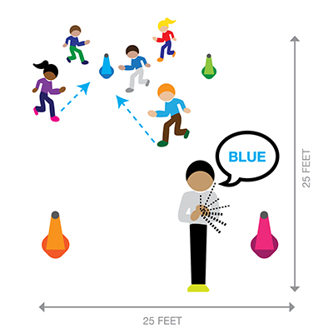
Easy: Dance to the cone
Medium: Change the number of claps
Hard: Pick more than one colour

